**INTERNSHIP REPORT**

**on**

**Web Developer Internship**

**Submitted By**

SUBMITTED TO THE SAVITRIBAI PHULE PUNE UNIVERSITY, PUNE IN THE PARTIAL FULFILLMENT OF THE REQUIREMENTS

FOR THE AWARD OF THE DEGREE

**BACHELOR OF ENGINEERING (INFORMATION TECHNOLOGY)**

**SUBMITTED BY**

**Mr. Dishank A Shekokare T19110816**

**Under the guidance of**

**PROF. Devika Rankhambe**

**Department of Information Technology**

|  |  |  |
| --- | --- | --- |
| Logo Shahu | **A.B.M.S. PARISHAD’S**  **ANANTRAO PAWAR COLLEGE OF ENGINEERING & RESEARCH**  Parvati, Pune-09  **NAAC Accredited Institute**  **SAVITRIBAI PHULE PUNE UNIVERSITY**  **2024-2025** |  |

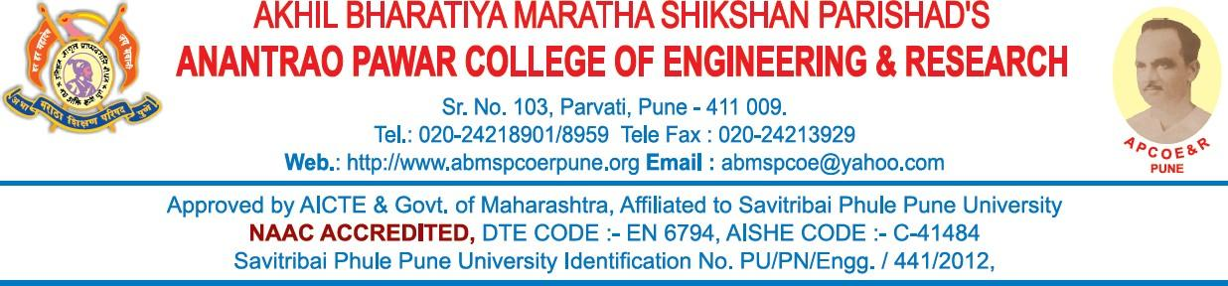

**DEPARTMENT OF INFORMATION TECHNOLOGY**

***CERTIFICATE***

This is to certify that the “**Internship Report**” has successfully completed the Internship entitled “**Web Developer”**. The report is the result of his/her efforts and endeavors. The Internship work is found worthy of acceptance as final. Internship report for academic year 2023-24.

**SUBMITTED BY**

**Mr. Dishank A Shekokare T19110816**

**PROF. Devika Rankhambe PROF. A.N. Kalal**

**Internship Guide** **Department Internship Coordinator**

INFORMATION TECHNOLOGY INFORMATION TECHNOLOGY

**PROF. A.A. Kadam Dr. S. B. Thakare**

**Head of Department Principal**

INFORMATION TECHNOLOGY

# CERTIFICATE OF INTERNSHIP

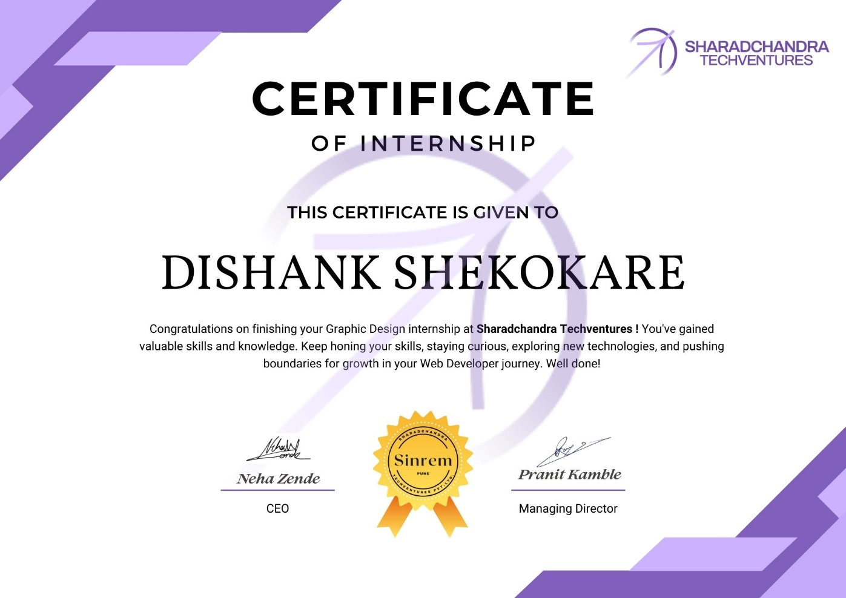

**III**

## ACKNOWLEDGEMENT

First, I would like to thank Miss Neha Zende, Founder of **Sinrem** for giving me the opportunity to do an internship within the organization. It is indeed with a great sense of pleasure and immense sense of gratitude that I acknowledge the help of these individuals. I am highly indebted to Principal **Dr. S. B. THAKARE**, for the facilities provided to accomplish this internship. I would like to thank my Head of the Department **Dr A. A. Kadam** for his constructive criticism throughout my internship. I would like to thank **Prof. Devika Rankhambe,** Guide of Internship, **Prof A. N. KALAL** internship coordinator Department of IT for their support and advice to get and complete internship in the above said organization. I am extremely grateful to my department staff members and friends who helped me in successful completion of this internship.

**Dishank A Shekokare**

**(T191108516)**

**IV**

**ABSTRACT**

This report presents a comprehensive overview of a dynamic internship experience within the field of web development, undertaken at a leading technology firm. The internship spanned a period of six months, during which the intern was immersed in both the front-end and back-end aspects of web development. The objective of the internship was twofold: to acquire a hands-on understanding of modern web development practices and to contribute to the development of innovative web applications that meet the evolving needs of users. The report begins by detailing the intern's initial integration into the web development team, highlighting the learning curve associated with understanding the company's development stack, which included languages such as HTML, CSS, JavaScript

**V**

**INDEX**

|  |  |  |
| --- | --- | --- |
| **S.NO** | **CONTENTS** | **PAGE NO** |
| **1.** | Introduction | 8 |
|  | **1.1** Organization Information | 9 |
|  | **1.2** About Program | 9 |
|  | **1.3** Program Opportunities | 9 |
| **2.** | Software Requirements | 10 |
| **3.** | Internship Description | 11 |
|  | **3.1.** HTML | 11 |
|  | **3.2** CSS | 12 |
|  | **3.3** BOOTSTRAP | 13 |
|  | **3.4**  REACT | 14 |
|  | **3.5** NODE JS | 15 |
|  | **3.6** EXPRESS JS | 15 |
| **4.** | Codes | 16 |
|  | **4.1** Old Age home Website | 16 |
| **5.** | Conclusion | 31 |

**VI**

**Learning Objectives/Internship Objectives**

Internships are generally thought of to be reserved for college students looking to gain experience in a particular field. However, a wide array of people can benefit from Training Internships in order to receive real world experience and develop their skills. An objective for this position should emphasize the skills you already possess in the area and your interest in learning more. Internships are utilized in a number of different career fields, including architecture, engineering, healthcare, economics, advertising and many more.

Some internships are used to allow individuals to perform scientific research while others are specifically designed to allow people to gain first-hand experience working. Utilizing internships is a great way to build your resume and develop skills that can be emphasized in your resume for future jobs. When you are applying for a Training Internship, make sure to highlight any special skills or talents that can make you stand apart from the rest of the applicants so that you have an improved chance of landing the position.

**VII**

1. **INTRODUCTION**

As technology advances internet is becoming ever popular. Website has become an essential part. Often website of an institution is used as major requirements to rate it. Thus, having a website is essential for any major organization. As one of the departments of a top public university in Bangladesh, Department of Accounting & Information Systems needs to have a useful and stunning website to showcase the department and use as a medium to interact with students, teachers and others. Notice, research works, club activities, digital local library etc. can be the major advantages of a website. On this project we will develop a website for the Department. On this report almost every details that is necessary has been discussed. Although maximum effort has been given to estimate events and expenses. There are some optional features that can be included or excluded. ERP software solution costs around BDT 32000 and it was excluded taking into account specialist so a third party has been selected to host the website. It will cost around BDT36000 a year. But the plus point is we will get 24/7 support. Cost can be minimized in this section, but maintenance has been given priority over cost. Detailed task list and Gantt charts has been included in the appendix to get clear picture of the project. Every possible disclosure has been made to cover maximum areas of the project. This report can be amended and changes can be made upon request from the stakeholders. The work will be done by a team with a supervisor from faculty member. So, no profit has been added. Only extra charges for different roles has been added. The senior web developer is an experienced person with excellent database handling record. A formal training phase is included in the project to train faculty members and office staffs on how to handle the website. Overall, a useful website can be really helpful for the department.

**Programs and opportunities:**

Front-end development has evolved rapidly over the past decade, becoming a cornerstone of the web development industry. As the internet has grown more integral to our daily lives, the demand for skilled front-end developers has surged, leading to the emergence of numerous programs and opportunities aimed at nurturing talent in this domain. Below, we explore various avenues through which aspiring front-end developers can sharpen their skills, build impressive portfolios, and embark on rewarding careers.

The field of front-end development is ever-evolving, with new tools, frameworks, and best practices emerging regularly. Continuous learning through online resources, workshops, and courses is essential to stay up-to-date and competitive in the industry. In conclusion, the journey to becoming a proficient front-end developer is filled with diverse learning paths and opportunities. By leveraging the myriad of resources available, aspiring developers can build a solid foundation, stay ahead in the industry, and ultimately, forge a successful career in front-end development.

**Program Benefits:**

A front-end development internship offers a multitude of benefits, especially for individuals looking to break into the tech industry or transition into a web development role. These benefits span practical skills acquisition, professional development, and personal growth.

**Hands-On Experience**

Real-World Projects: Interns work on actual projects, which provides invaluable insight into the day-to-day responsibilities of a front-end developer. This hands-on experience is vital for understanding how concepts learned in academic settings apply in a professional environment.

Technical Skill Enhancement: Interns get the chance to refine and expand their coding skills, including HTML, CSS, JavaScript, and frameworks like React, Vue.js, or React. This exposure is crucial for mastering front-end development.

**Best Part:**

A great benefit of your participation in an internship is that upon completion, you will receive a certificate that you can add to your resume and LinkedIn profile! Personal branding is important. Showcasing your efforts towards personal and career development outside of study requirements is an awesome way to demonstrate your willingness to learn!

The best part of a front-end internship is the rich, hands-on experience gained through real-world projects, coupled with the invaluable opportunity to learn directly from experienced professionals. This environment fosters not only the enhancement of technical skills but also promotes personal growth through mentorship and feedback. Interns benefit from the chance to collaborate closely with teams, contributing creative solutions and learning to navigate the complexities of professional workflows. Such experiences are further enriched by the development of soft skills, like communication and problem-solving, and the opportunity to build a professional network, all of which are crucial for a budding front-end developer’s career.

**2. SOFTWARE REQUIREMENTS**

**System configurations:**

The software requirement specification can be produced at the culmination of the analysis task. The function and performance allocated to software as part of system engineering are refined by establishing a complete information description, a detailed functional description, a representation of system behavior, and indication of performance and design constraints, appropriate validate criteria, and other information pertinent to requirements.

**Software Requirements**:

* Operating system: Windows 10.
* Web Technologies: HTML, CSS, BOOTSTRAP, REACT, NODE JS, EXPRESS JS.
* Data Base : SQL Server 8.0.29.

**3. INTERNSHIP DESCRIPTION**

**3.1 HTML:**

The **Hyper Text Markup Language** or **HTML** is the standard [markup language](https://en.wikipedia.org/wiki/Markup_language) for documents designed to be displayed in a [web browser](https://en.wikipedia.org/wiki/Web_browser). It can be assisted by technologies such as [Cascading Style Sheets](https://en.wikipedia.org/wiki/Cascading_Style_Sheets) (CSS) and [scripting languages](https://en.wikipedia.org/wiki/Scripting_language) such as [JavaScript](https://en.wikipedia.org/wiki/JavaScript).

[Web browsers](https://en.wikipedia.org/wiki/Web_browser) receive HTML documents from a [web server](https://en.wikipedia.org/wiki/Web_server) or from local storage and [render](https://en.wikipedia.org/wiki/Browser_engine) the documents into multimedia web pages. HTML describes the structure of a [web page](https://en.wikipedia.org/wiki/Web_page) [semantically](https://en.wikipedia.org/wiki/Semantic_Web) and originally included cues for the appearance of the document.

[HTML elements](https://en.wikipedia.org/wiki/HTML_element) are the building blocks of HTML pages. With HTML constructs, [images](https://en.wikipedia.org/wiki/HTML_element#Images_and_objects) and other objects such as [interactive forms](https://en.wikipedia.org/wiki/Fieldset) may be embedded into the rendered page. HTML provides a means to create [structured documents](https://en.wikipedia.org/wiki/Structured_document) by denoting structural [semantics](https://en.wikipedia.org/wiki/Semantics) for text such as headings, paragraphs, lists, [links](https://en.wikipedia.org/wiki/Hyperlink), quotes and other items. HTML elements are delineated by *tags*, written using [angle brackets](https://en.wikipedia.org/wiki/Bracket#Angle_brackets). Tags such as <**img** /> and <**input** /> directly introduce content into the page. Other tags such as <**p**> surround and provide information about document text and may include other tags as sub-elements. Browsers do not display the HTML tags but use them to interpret the content of the page.

HTML can embed programs written in a [scripting language](https://en.wikipedia.org/wiki/Scripting_language) such as [JavaScript](https://en.wikipedia.org/wiki/JavaScript), which affects the behavior and content of web pages. Inclusion of CSS defines the look and layout of content. The [World Wide Web Consortium](https://en.wikipedia.org/wiki/World_Wide_Web_Consortium) (W3C), former maintainer of the HTML and current maintainer of the CSS standards, has encouraged the use of CSS over explicit presentational HTML since 1997.[[2]](https://en.wikipedia.org/wiki/HTML#cite_note-deprecated-2) A form of HTML, known as [HTML5](https://en.wikipedia.org/wiki/HTML5), is used to display video and audio, primarily using the <**canvas**> element, in collaboration with JavaScript.

As of version 4.0, HTML defines a set of 252 [character entity references](https://en.wikipedia.org/wiki/Character_entity_reference) and a set of 1,114,050 [numeric character references](https://en.wikipedia.org/wiki/Numeric_character_reference), both of which allow individual characters to be written via simple markup, rather than literally. A literal character and its markup counterpart are considered equivalent and are rendered identically.

The ability to "[escape](https://en.wikipedia.org/wiki/Escape_character)" characters in this way allows for the characters < and & (when written as &lt; and &amp;, respectively) to be interpreted as character data, rather than markup. For example, a literal < normally indicates the start of a tag, and & normally indicates the start of a character entity reference or numeric character reference; writing it as &amp; or &#x26; or &#38; allows & to be included in the content of an element or in the value of an attribute. The double-quote character ("), when not used to quote an attribute value, must also be escaped as &quote; or &#x22; or &#34; when it appears within the attribute value itself. Equivalently, the single-quote character ('), when not used to quote an attribute value, must also be escaped as &#x27; or &#39; (or as &apos; in HTML5 or XHTML documents[[78]](https://en.wikipedia.org/wiki/HTML#cite_note-78)[[79]](https://en.wikipedia.org/wiki/HTML#cite_note-aposhtml-79)) when it appears within the attribute value itself. If document authors overlook the need to escape such characters, some browsers can be very forgiving and try to use context to guess their intent.

**3.2 CSS:**

CSS was first proposed by [Håkon Wium Lie](https://en.wikipedia.org/wiki/H%C3%A5kon_Wium_Lie) on 10 October 1994.[[22]](https://en.wikipedia.org/wiki/CSS#cite_note-chss-proposal-22) At the time, Lie was working with [Tim Berners-Lee](https://en.wikipedia.org/wiki/Tim_Berners-Lee) at [CERN](https://en.wikipedia.org/wiki/CERN).[[23]](https://en.wikipedia.org/wiki/CSS#cite_note-chapter20-23) Several other style sheet languages for the web were proposed around the same time, and discussions on public mailing lists and inside [World Wide Web Consortium](https://en.wikipedia.org/wiki/World_Wide_Web_Consortium) resulted in the first W3C CSS Recommendation (CSS1)[[24]](https://en.wikipedia.org/wiki/CSS#cite_note-w3c-css1-24) being released in 1996. In particular, a proposal by [Bert Bos](https://en.wikipedia.org/wiki/Bert_Bos) was influential; he became co-author of CSS1, and is regarded as co-creator of CSS.[[25]](https://en.wikipedia.org/wiki/CSS#cite_note-WWW3-25)

Style sheets have existed in one form or another since the beginnings of Standard Generalized Markup Language ([SGML](https://en.wikipedia.org/wiki/SGML)) in the 1980s, and CSS was developed to provide style sheets for the web.[[26]](https://en.wikipedia.org/wiki/CSS#cite_note-css-phd-26) One requirement for a web style sheet language was for style sheets to come from different sources on the web. Therefore, existing style sheet languages like [DSSSL](https://en.wikipedia.org/wiki/Document_Style_Semantics_and_Specification_Language) and [FOSI](https://en.wikipedia.org/wiki/Formatting_Output_Specification_Instance) were not suitable. CSS, on the other hand, let a document's style be influenced by multiple style sheets by way of "cascading" styles.[[26]](https://en.wikipedia.org/wiki/CSS#cite_note-css-phd-26)

As HTML grew, it came to encompass a wider variety of stylistic capabilities to meet the demands of [web developers](https://en.wikipedia.org/wiki/Web_development). This evolution gave the designer more control over site appearance, at the cost of more complex HTML. Variations in [web browser](https://en.wikipedia.org/wiki/Web_browser) implementations, such as [ViolaWWW](https://en.wikipedia.org/wiki/ViolaWWW) and [WorldWideWeb](https://en.wikipedia.org/wiki/WorldWideWeb),[[27]](https://en.wikipedia.org/wiki/CSS#cite_note-IEEE-27) made consistent site appearance difficult, and users had less control over how web content was displayed. The browser/editor developed by Tim Berners-Lee had style sheets that were hard-coded into the program. The style sheets could therefore not be linked to documents on the web.[[23]](https://en.wikipedia.org/wiki/CSS#cite_note-chapter20-23) [Robert Cailliau](https://en.wikipedia.org/wiki/Robert_Cailliau), also of CERN, wanted to separate the structure from the presentation so that different style sheets could describe different presentation for printing, screen-based presentations, and editors.[[27]](https://en.wikipedia.org/wiki/CSS#cite_note-IEEE-27)

Improving web presentation capabilities was a topic of interest to many in the web community and nine different style sheet languages were proposed on the www-style mailing list.[[26]](https://en.wikipedia.org/wiki/CSS#cite_note-css-phd-26) Of these nine proposals, two were especially influential on what became CSS: Cascading HTML Style Sheets[[22]](https://en.wikipedia.org/wiki/CSS#cite_note-chss-proposal-22) and Stream-based Style Sheet Proposal (SSP).[[25]](https://en.wikipedia.org/wiki/CSS#cite_note-WWW3-25)[[28]](https://en.wikipedia.org/wiki/CSS#cite_note-ssp-28) Two browsers served as testbeds for the initial proposals; Lie worked with [Yves Lafon](https://en.wikipedia.org/w/index.php?title=Yves_Lafon&action=edit&redlink=1) to implement CSS in [Dave Raggett](https://en.wikipedia.org/wiki/Dave_Raggett)'s [Arena](https://en.wikipedia.org/wiki/Arena_(web_browser)) browser.[[29]](https://en.wikipedia.org/wiki/CSS#cite_note-29)[[30]](https://en.wikipedia.org/wiki/CSS#cite_note-30)[[31]](https://en.wikipedia.org/wiki/CSS#cite_note-31) Bert Bos implemented his own SSP proposal in the [Argo](https://en.wikipedia.org/wiki/Argo_(web_browser)) browser.[[25]](https://en.wikipedia.org/wiki/CSS#cite_note-WWW3-25) Thereafter, Lie and Bos worked together to develop the CSS standard (the 'H' was removed from the name because these style sheets could also be applied to other markup languages besides HTML).[[23]](https://en.wikipedia.org/wiki/CSS#cite_note-chapter20-23)

CSS is designed to enable the separation of presentation and content, including [layout](https://en.wikipedia.org/wiki/Page_layout), [colors](https://en.wikipedia.org/wiki/Color), and [fonts](https://en.wikipedia.org/wiki/Typeface).[[3]](https://en.wikipedia.org/wiki/CSS#cite_note-3) This separation can improve content [accessibility](https://en.wikipedia.org/wiki/Accessibility); provide more flexibility and control in the specification of presentation characteristics; enable multiple [web pages](https://en.wikipedia.org/wiki/Web_page) to share formatting by specifying the relevant CSS in a separate .css file, which reduces complexity and repetition in the structural content; and enable the .css file to be [cached](https://en.wikipedia.org/wiki/Cache_(computing)) to improve the page load speed between the pages that share the file and its formatting.

Separation of formatting and content also makes it feasible to present the same markup page in different styles for different rendering methods, such as on-screen, in print, by voice (via speech-based browser or [screen reader](https://en.wikipedia.org/wiki/Screen_reader)), and on [Braille-based](https://en.wikipedia.org/wiki/Braille_display) tactile devices. CSS also has rules for alternate formatting if the content is accessed on a [mobile device](https://en.wikipedia.org/wiki/Mobile_device).[[4]](https://en.wikipedia.org/wiki/CSS#cite_note-4)

**3.4 BOOTSTRAP:**

Bootstrap is an HTML, CSS & JS Library that focuses on simplifying the development of informative web pages (as opposed to [web apps](https://en.wikipedia.org/wiki/Web_Apps)). The primary purpose of adding it to a web project is to apply Bootstrap's choices of color, size, font and layout to that project. As such, the primary factor is whether the developers in charge find those choices to their liking. Once added to a project, Bootstrap provides basic style definitions for all [HTML elements](https://en.wikipedia.org/wiki/HTML_element). The result is a uniform appearance for prose, tables and form elements across [web browsers](https://en.wikipedia.org/wiki/Web_browser). In addition, developers can take advantage of CSS classes defined in Bootstrap to further customize the appearance of their contents. For example, Bootstrap has provisioned for light- and dark-coloured tables, page headings, more prominent [pull quotes](https://en.wikipedia.org/wiki/Pull_quote), and text with a highlight.

Bootstrap also comes with several JavaScript components in the form of [jQuery](https://en.wikipedia.org/wiki/JQuery) plugins. They provide additional user interface elements such as [dialog boxes](https://en.wikipedia.org/wiki/Dialog_box), [tooltips](https://en.wikipedia.org/wiki/Tooltip), and carousels. Each Bootstrap component consists of an HTML structure, CSS declarations, and in some cases accompanying JavaScript code. They also extend the functionality of some existing interface elements, including for example an auto-complete function for input fields.

[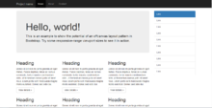](https://en.wikipedia.org/wiki/File:Twitter_Bootstrap_Under_Firefox_32.png)

Example of a webpage using Bootstrap framework rendered in [Firefox](https://en.wikipedia.org/wiki/Firefox)

The most prominent components of Bootstrap are its layout components, as they affect an entire web page. The basic layout component is called "Container", as every other element in the page is placed in it. Developers can choose between a fixed-width container and a fluid-width container. While the latter always fills the width of the web page, the former uses one of the five predefined fixed widths, depending on the size of the screen showing the page:

* Smaller than 576 pixels
* 576–768 pixels
* 768–992 pixels
* 992–1200 pixels
* Larger than 1200 pixels

A precompiled version of Bootstrap is available in the form of one CSS file and three JavaScript files that can be readily added to any project. The raw form of Bootstrap, however, enables developers to implement further customization and size optimizations. This raw form is modular, meaning that the developer can remove unneeded components, apply a theme and modify the uncompiled [Sass](https://en.wikipedia.org/wiki/Sass_(stylesheet_language)) files.

**3.5 REACT JS:**

ReactJS was a [JavaScript](https://en.wikipedia.org/wiki/JavaScript)-based [open-source](https://en.wikipedia.org/wiki/Open-source) front-end [web framework](https://en.wikipedia.org/wiki/Web_framework) for developing [single-page applications](https://en.wikipedia.org/wiki/Single-page_application). It was maintained mainly by [Google](https://en.wikipedia.org/wiki/Google) and a community of individuals and corporations. It aimed to simplify both the development and the [testing](https://en.wikipedia.org/wiki/Software_testing) of such applications by providing a framework for client-side [model–view–controller](https://en.wikipedia.org/wiki/Model%E2%80%93view%E2%80%93controller) (MVC) and [model–view–viewmodel](https://en.wikipedia.org/wiki/Model%E2%80%93view%E2%80%93viewmodel) (MVVM) architectures, along with components commonly used in [web applications](https://en.wikipedia.org/wiki/Web_application) and [progressive web applications](https://en.wikipedia.org/wiki/Progressive_web_application).

ReactJS was used as the frontend of the [MERN](https://en.wikipedia.org/wiki/MEAN_(software_bundle)) stack, that consisted of [MongoDB](https://en.wikipedia.org/wiki/MongoDB) database, [Express.js](https://en.wikipedia.org/wiki/Express.js) web application server framework, ReactJS itself (or [React](https://en.wikipedia.org/wiki/Angular_(application_platform))), and [Node.js](https://en.wikipedia.org/wiki/Node.js) server runtime environment.

As of January 1, 2022, Google no longer updates ReactJS to fix security, browser compatibility, or [jQuery](https://en.wikipedia.org/wiki/JQuery) issues.[[3]](https://en.wikipedia.org/wiki/AngularJS#cite_note-3)[[4]](https://en.wikipedia.org/wiki/AngularJS#cite_note-:1-4)[[5]](https://en.wikipedia.org/wiki/AngularJS#cite_note-:0-5) The React team recommends upgrading to [React (v2+)](https://en.wikipedia.org/wiki/Angular_(web_framework)) as the best path forward, but they also provided some other options.

The ReactJS framework worked by first reading the [Hypertext Markup Language](https://en.wikipedia.org/wiki/Hypertext_Markup_Language) (HTML) page, which had additional custom [HTML attributes](https://en.wikipedia.org/wiki/HTML_attribute) embedded into it. React interpreted those attributes as [directives](https://en.wikipedia.org/wiki/Directive_(programming)) to bind input or output parts of the page to a model that is represented by standard JavaScript [variables](https://en.wikipedia.org/wiki/Variable_(computer_science)). The values of those JavaScript variables could be manually set within the code or retrieved from static or dynamic [JSON](https://en.wikipedia.org/wiki/JSON) resources.

ReactJS was built on the belief that [declarative programming](https://en.wikipedia.org/wiki/Declarative_programming) should be used to create [user interfaces](https://en.wikipedia.org/wiki/User_interface) and connect [software components](https://en.wikipedia.org/wiki/Software_component), while [imperative programming](https://en.wikipedia.org/wiki/Imperative_programming) was better suited to defining an application's [business logic](https://en.wikipedia.org/wiki/Business_logic).[[7]](https://en.wikipedia.org/wiki/AngularJS#cite_note-7) The framework adapted and extended traditional HTML to present dynamic content through two-way data-binding that allowed for the automatic synchronization of models and views. As a result, ReactJS de-emphasized explicit [Document Object Model](https://en.wikipedia.org/wiki/Document_Object_Model) (DOM) manipulation with the goal of improving testability and performance.

ReactJS's design goals included:

* to decouple DOM manipulation from application logic. The difficulty of this is dramatically affected by the way the code is structured.
* to decouple the client side of an application from the server-side. This allows development work to progress in parallel and allows for reuse of both sides.
* to provide structure for the journey of building an application: from designing the UI, through writing the business logic, to testing.

ReactJS implemented the MVC pattern to separate presentation, data, and logic components.[[8]](https://en.wikipedia.org/wiki/AngularJS#cite_note-8) Using [dependency injection](https://en.wikipedia.org/wiki/Dependency_injection), React brought traditionally [server-side](https://en.wikipedia.org/wiki/Server-side) services, such as view-dependent controllers, to client-side web applications. Consequently, much of the burden on the server could be reduced.

**3.6 NODE JS:**

Node.js is an [open-source](https://en.wikipedia.org/wiki/Open-source_software), [cross-platform](https://en.wikipedia.org/wiki/Cross-platform), [back-end](https://en.wikipedia.org/wiki/Front_end_and_back_end) [JavaScript](https://en.wikipedia.org/wiki/JavaScript) [runtime environment](https://en.wikipedia.org/wiki/Runtime_system) that runs on the [V8 engine](https://en.wikipedia.org/wiki/V8_(JavaScript_engine)) and executes JavaScript code outside a [web browser](https://en.wikipedia.org/wiki/Web_browser). Node.js lets developers use JavaScript to write command line tools and for [server-side scripting](https://en.wikipedia.org/wiki/Server-side_scripting)—running scripts server-side to produce [dynamic web page](https://en.wikipedia.org/wiki/Dynamic_web_page) content before the page is sent to the user's web browser. Consequently, Node.js represents a "JavaScript everywhere" paradigm,[[6]](https://en.wikipedia.org/wiki/Node.js#cite_note-6) unifying [web-application](https://en.wikipedia.org/wiki/Web_application) development around a single programming language, rather than different languages for server-side and client-side scripts.

Node.js has an [event-driven architecture](https://en.wikipedia.org/wiki/Event-driven_architecture) capable of [asynchronous I/O](https://en.wikipedia.org/wiki/Asynchronous_I/O). These design choices aim to optimize [throughput](https://en.wikipedia.org/wiki/Throughput) and [scalability](https://en.wikipedia.org/wiki/Scalability) in web applications with many input/output operations, as well as for [real-time Web](https://en.wikipedia.org/wiki/Real-time_Web) applications (e.g., [real-time communication](https://en.wikipedia.org/wiki/Real-time_communication) programs and [browser games](https://en.wikipedia.org/wiki/Browser_game)).[[7]](https://en.wikipedia.org/wiki/Node.js#cite_note-readwrite-7)

The Node.js [distributed development](https://en.wikipedia.org/wiki/Distributed_development) project was previously governed by the Node.js Foundation,[[8]](https://en.wikipedia.org/wiki/Node.js#cite_note-8) and has now merged with the [JS Foundation](https://en.wikipedia.org/wiki/JS_Foundation) to form the [OpenJS Foundation](https://en.wikipedia.org/wiki/OpenJS_Foundation), which is facilitated by the [Linux Foundation](https://en.wikipedia.org/wiki/Linux_Foundation)'s Collaborative Projects program.[[9]](https://en.wikipedia.org/wiki/Node.js#cite_note-9)

**3.7 EXPRESS JS:**

Express.js, or simply Express, is a [back end](https://en.wikipedia.org/wiki/Front_end_and_back_end) [web application framework](https://en.wikipedia.org/wiki/Web_application_framework) for [Node.js](https://en.wikipedia.org/wiki/Node.js), released as [free and open-source software](https://en.wikipedia.org/wiki/Free_and_open-source_software) under the [MIT License](https://en.wikipedia.org/wiki/MIT_License). It is designed for building [web applications](https://en.wikipedia.org/wiki/Web_application) and [APIs](https://en.wikipedia.org/wiki/API).[[3]](https://en.wikipedia.org/wiki/Express.js#cite_note-ExpressJS-3) It has been called the [de facto standard](https://en.wikipedia.org/wiki/De_facto_standard) server framework for [Node.js](https://en.wikipedia.org/wiki/Node.js).[[4]](https://en.wikipedia.org/wiki/Express.js#cite_note-4)

The original author, TJ Holowaychuk, described it as a [Sinatra](https://en.wikipedia.org/wiki/Sinatra_(software))-inspired server,[[5]](https://en.wikipedia.org/wiki/Express.js#cite_note-5) meaning that it is relatively minimal with many features available as plugins. Express is the back-end component of popular development stacks like the [MEAN](https://en.wikipedia.org/wiki/MEAN_(software_bundle)), MERN or MEVN stack, together with the [MongoDB](https://en.wikipedia.org/wiki/MongoDB) database software and a [JavaScript](https://en.wikipedia.org/wiki/JavaScript) front-end framework or library.[[6]](https://en.wikipedia.org/wiki/Express.js#cite_note-MeanIO-6)

**4. CODES: 4.1 Landing Page CODE:**

<!DOCTYPE html>

<html>

<head>

<meta charset="utf-8" />

<meta http-equiv="X-UA-Compatible" content="IE=edge" />

<title>Palkar Foundation</title>

<meta

name="viewport"

content="width=device-width, initial-scale=1, shrink-to-fit=no"

/>

<meta name="description" content="" />

<meta name="keywords" content="" />

<meta name="author" content="" />

<link

rel="stylesheet"

type="text/css"

href="//fonts.googleapis.com/css?family=|Roboto+Sans:400,700|Playfair+Display:400,700"

/>

<link rel="stylesheet" href="css/bootstrap.min.css" />

<link rel="stylesheet" href="css/animate.css" />

<link rel="stylesheet" href="css/owl.carousel.min.css" />

<link rel="stylesheet" href="css/aos.css" />

<link rel="stylesheet" href="css/bootstrap-datepicker.css" />

<link rel="stylesheet" href="css/jquery.timepicker.css" />

<link rel="stylesheet" href="css/fancybox.min.css" />

<link rel="stylesheet" href="fonts/ionicons/css/ionicons.min.css" />

<link rel="stylesheet" href="fonts/fontawesome/css/font-awesome.min.css" />

<!-- Theme Style -->

<link rel="stylesheet" href="css/style.css" />

</head>

<body>

<div class="head-container">

<div class="nav scrolled" id="nav">

<input type="checkbox" name="click" id="click" />

<label for="click" class="bars">

<i class="fa fa-bars"></i>

</label>

<div class="menu">

<img src="images/logorm.png" alt="" />

<a href="index.html" class="menu-items">Home</a>

<a href="rooms.html" class="menu-items">Booking Room</a>

<a href="events.html" class="menu-items">Services</a>

<a href="login.html" class="menu-items">Login</a>

<a href="about.html" class="menu-items">Contact Us</a>

</div>

</div>

</div>

<section

class="site-hero overlay"

style="background-image: url(images/hero_4.png)"

data-stellar-background-ratio="0.5"

>

<div class="container">

<div

class="row site-hero-inner justify-content-center align-items-center"

>

<div class="col-md-10 text-center" data-aos="fade-up">

<span class="custom-caption text-uppercase text-white d-block mb-3"

>Welcome Palkar Foundation</span

>

<h1 class="heading">A Best Place To Stay</h1>

<br />

<p style="color: white; size: 30px">

Enjoy the best second part of your life and welcome to Palkar's

Home. They might need particular attention and care, which many

family members might not be able to provide. The purpose of Home

is to offer an establishment for the care of elderly people. A

series of medical and psychological problems would have eventually

caught up with them. This may sometimes even make it more

difficult for them to do their daily duties. After a life of

laborious work and obligations, the goal of Palkar's Home for

Senior Citizens is to give the elderly a life of comfort and

quiet.

</p>

</div>

</div>

</div>

</section>

<!-- END section -->

<section class="section bg-light pb-0">

<div class="container">

<div class="row check-availabilty" id="next">

<div class="block-32" data-aos="fade-up" data-aos-offset="-200">

<form action="#">

<div class="row">

<div class="col-md-6 mb-3 mb-lg-0 col-lg-3">

<label for="checkin_date" class="font-weight-bold text-black"

>Check In</label

>

<div class="field-icon-wrap">

<div class="icon"><span class="icon-calendar"></span></div>

<input type="text" id="checkin_date" class="form-control" />

</div>

</div>

<div class="col-md-6 mb-3 mb-lg-0 col-lg-3">

<label for="checkout_date" class="font-weight-bold text-black"

>Check Out</label

>

<div class="field-icon-wrap">

<div class="icon"><span class="icon-calendar"></span></div>

<input

type="text"

id="checkout_date"

class="form-control"

/>

</div>

</div>

<div class="col-md-6 mb-3 mb-md-0 col-lg-3">

<div class="row">

<div class="col-md-6 mb-3 mb-md-0">

<label for="adults" class="font-weight-bold text-black"

>Adults</label

>

<div class="field-icon-wrap">

<div class="icon">

<span class="ion-ios-arrow-down"></span>

</div>

<select name="" id="adults" class="form-control">

<option value="">1</option>

<option value="">2</option>

<option value="">3</option>

<option value="">4+</option>

</select>

</div>

</div>

</div>

</div>

<div class="col-md-6 col-lg-3 align-self-end">

<button class="btn btn-primary btn-block text-white">

Check Availabilty

</button>

</div>

</div>

</form>

</div>

</div>

</div>

</section>

<section class="py-5 bg-light">

<div class="container">

<div class="row align-items-center">

<div

class="col-md-12 col-lg-7 ml-auto order-lg-2 position-relative mb-5"

data-aos="fade-up"

>

<img

src="images/food-1.jpg"

alt="Image"

class="img-fluid rounded"

/>

</div>

<div class="col-md-12 col-lg-4 order-lg-1" data-aos="fade-up">

<h2 class="heading">Welcome!</h2>

<p class="mb-4">

Our goal is to provide the best possible high-quality care that is

individualized to address each resident's unique medical, social,

and spiritual needs.

</p>

<p>

<a

href="https://palkarfoundation.com/files/Palkars-Home-Senior-Citizen-Brochure.pdf"

class="btn btn-primary text-white py-2 mr-3"

>Download</a

>

</p>

</div>

</div>

</div>

</section>

<section

class="section bg-image overlay"

style="background-image: url('images/hero_4.jpg')"

>

<div class="container">

<div class="row align-items-center">

<div

class="col-12 col-md-6 text-center mb-4 mb-md-0 text-md-left"

data-aos="fade-up"

>

<h2 class="text-white font-weight-bold">

Give the gift of comfort and care. Your donation to the old age

home brings warmth to their golden years. Join us in making a

difference today.

</h2>

</div>

<div

class="col-12 col-md-6 text-center text-md-right"

data-aos="fade-up"

data-aos-delay="200"

>

<a

href="donation.html"

class="btn btn-outline-white-primary py-3 text-white px-5"

><b>Donate Now</b></a

>

</div>

</div>

</div>

</section>

<section class="section blog-post-entry bg-light">

<div class="container">

<div class="row justify-content-center text-center mb-5">

<div class="col-md-7">

<h2 class="heading" data-aos="fade-up">Services</h2>

<p data-aos="fade-up">

Every facility has been thoughtfully designed to guarantee the

senior population's maximum comfort and safety. The wonderful

experience required to live a happy life is provided by our

top-notch amenities.

</p>

</div>

</div>

<div class="row">

<div

class="col-lg-4 col-md-6 col-sm-6 col-12 post"

data-aos="fade-up"

data-aos-delay="100"

>

<div class="media media-custom d-block mb-4 h-100">

<!-- <a href="#" class="mb-4 d-block"><img src="images/img_1.jpg" alt="Image placeholder" class="img-fluid"></a> -->

<div class="media-body">

<h2 class="mt-0 mb-3"><a href="#">Foods and Delicacies</a></h2>

<p>

Nutritious Options: Our food delications are crafted with

attention to nutrition, incorporating fresh ingredients and

balanced meals to promote the health and well-being of

residents

</p>

</div>

</div>

</div>

<div

class="col-lg-4 col-md-6 col-sm-6 col-12 post"

data-aos="fade-up"

data-aos-delay="200"

>

<div class="media media-custom d-block mb-4 h-100">

<!-- <a href="#" class="mb-4 d-block"><img src="images/img_2.jpg" alt="Image placeholder" class="img-fluid"></a> -->

<div class="media-body">

<h2 class="mt-0 mb-3"><a href="#">Lounge room</a></h2>

<p>

- Additionally, Palkar's Home has lounge rooms where residents

can unwind, read a book, listen to music, or take part in

daily and weekly activities that are planned by the property

administration.

</p>

</div>

</div>

</div>

<div

class="col-lg-4 col-md-6 col-sm-6 col-12 post"

data-aos="fade-up"

data-aos-delay="300"

>

<div class="media media-custom d-block mb-4 h-100">

<!-- <a href="#" class="mb-4 d-block"><img src="images/img_3.jpg" alt="Image placeholder" class="img-fluid"></a> -->

<div class="media-body">

<h2 class="mt-0 mb-3"><a href="#">Environment</a></h2>

<p>

The occupants can fully appreciate nature here, surrounded by

lush vegetation. We have chosen a rental model so that people

won't have to consider making long-term investments. We still

provide a range of adaptable renting options.

</p>

</div>

</div>

</div>

<div><br /><br /></div>

<div class="know" data-aos="fade-up" data-aos-delay="200">

<a

href="events.html"

class="btn btn-outline-yellow-primary py-3 text-white px-5"

><b>Know more</b></a

>

</div>

</div>

</div>

</section>

<section class="section">

<div class="container">

<div class="row justify-content-center text-center mb-5">

<div class="col-md-7">

<h2 class="heading" data-aos="fade-up">Rooms &amp; Suites</h2>

<p data-aos="fade-up" data-aos-delay="100">

Palkar's Home's room designs are the result of careful

consideration. Every room is large and constructed to the highest

standards; it is fully furnished, and among other things, the

bathrooms have been created with the elderly in mind

</p>

</div>

</div>

<div class="row">

<div class="col-md-6 col-lg-4" data-aos="fade-up">

<a href="#" class="room">

<figure class="img-wrap">

<img

src="images/img_1.jpg"

alt="Free website template"

class="img-fluid mb-3"

/>

</figure>

<div class="p-3 text-center room-info">

<h2>Single Room</h2>

</div>

</a>

</div>

<div class="col-md-6 col-lg-4" data-aos="fade-up">

<a href="#" class="room">

<figure class="img-wrap">

<img

src="images/img_2.jpg"

alt="Free website template"

class="img-fluid mb-3"

/>

</figure>

<div class="p-3 text-center room-info">

<h2>Family Room</h2>

</div>

</a>

</div>

<div class="col-md-6 col-lg-4" data-aos="fade-up">

<a href="#" class="room">

<figure class="img-wrap">

<img

src="images/img_3.jpg"

alt="Free website template"

class="img-fluid mb-3"

/>

</figure>

<div class="p-3 text-center room-info">

<h2>Presidential Room</h2>

</div>

</a>

</div>

</div>

</div>

</section>

<section class="section slider-section bg-light">

<div class="container">

<div class="row justify-content-center text-center mb-5">

<div class="col-md-7">

<h2 class="heading" data-aos="fade-up">Photos</h2>

<p data-aos="fade-up" data-aos-delay="100">

Our goal is to provide the best possible high-quality care that is

individualized to address each resident's unique medical, social,

and spiritual needs.

</p>

</div>

</div>

<div class="row">

<div class="col-md-12">

<div

class="home-slider major-caousel owl-carousel mb-5"

data-aos="fade-up"

data-aos-delay="200"

>

<div class="slider-item">

<a

href="images/slider-1.jpg"

data-fancybox="images"

data-caption="Caption for this image"

><img

src="images/slider-1.jpg"

alt="Image placeholder"

class="img-fluid"

/></a>

</div>

<div class="slider-item">

<a

href="images/slider-2.jpg"

data-fancybox="images"

data-caption="Caption for this image"

><img

src="images/slider-2.jpg"

alt="Image placeholder"

class="img-fluid"

/></a>

</div>

<div class="slider-item">

<a

href="images/slider-3.jpg"

data-fancybox="images"

data-caption="Caption for this image"

><img

src="images/slider-3.jpg"

alt="Image placeholder"

class="img-fluid"

/></a>

</div>

<div class="slider-item">

<a

href="images/slider-4.jpg"

data-fancybox="images"

data-caption="Caption for this image"

><img

src="images/slider-4.jpg"

alt="Image placeholder"

class="img-fluid"

/></a>

</div>

<div class="slider-item">

<a

href="images/slider-5.jpg"

data-fancybox="images"

data-caption="Caption for this image"

>

<img

src="images/slider-5.jpg"

alt="Image placeholder"

class="img-fluid"

/></a>

</div>

</div>

<!-- END slider -->

</div>

</div>

</div>

</section>

<!-- END section -->

<!-- END section -->

<section class="section testimonial-section">

<div class="container">

<div class="row justify-content-center text-center mb-5">

<div class="col-md-7">

<h2 class="heading" data-aos="fade-up">People Says</h2>

</div>

</div>

<div class="row">

<div

class="js-carousel-2 owl-carousel mb-5"

data-aos="fade-up"

data-aos-delay="200"

>

<div

class="testimonial text-center slider-item border border-black bg-white rounded-md p-5 shadow-md"

>

<div class="author-image mb-3">

<img

src="images/person_1.jpg"

alt="Image placeholder"

class="rounded-circle mx-auto"

/>

</div>

<blockquote>

<p>

&ldquo;We landed here yesterday evening and plan to stay until

5th January. This place is simply great. Very beautiful

surroundings, nice and friendly staff, very clean and nice

room, bathroom. Yesterday dinner and today breakfast were

tasty too. I am tempted to stay here on a long term basis.

This was a great new year eve idea and a nice place to become

new year. Happy new year, Thanks for your suggestion&rdquo;

</p>

</blockquote>

<p><em>&mdash; Dr. Shrihari Marathe</em></p>

</div>

<div

class="testimonial text-center slider-item border border-black bg-white rounded-md p-5 shadow-md"

>

<div class="author-image mb-3">

<img

src="images/person_2.jpg"

alt="Image placeholder"

class="rounded-circle mx-auto"

/>

</div>

<blockquote>

<p>

&ldquo;This place is simply great. Very beautiful

surroundings, nice and friendly staff, very clean and nice

room, bathroom. Yesterday dinner and today breakfast were

tasty too. I am tempted to stay here on a long term basis.

This was a great new year eve idea and a nice place to

become new year.&rdquo;

</p>

</blockquote>

<p><em>&mdash; Dr. Shrihari Marathe</em></p>

</div>

<div

class="testimonial text-center slider-item border border-black bg-white rounded-md p-5 shadow-md"

>

<div class="author-image mb-3">

<img

src="images/person_3.jpg"

alt="Image placeholder"

class="rounded-circle mx-auto"

/>

</div>

<blockquote>

<p>

&ldquo;Palkar Foundation provides a serene haven for seniors

seeking comfort and care. The dedicated staff exhibits genuine

warmth and attentiveness, creating a supportive community. The

well-maintained accommodations offer a blend of functionality

and aesthetics. Residents can engage in various activities,

fostering a sense of community and well-being. Plakar

Foundation stands out for its commitment to providing a

peaceful and enriching environment for the elderly.&rdquo;

</p>

</blockquote>

<p><em>&mdash; Dr. Shrihari Marathe</em></p>

</div>

<div

class="testimonial text-center slider-item border border-black bg-white rounded-md p-5 shadow-md"

>

<div class="author-image mb-3">

<img

src="images/person_1.jpg"

alt="Image placeholder"

class="rounded-circle mx-auto"

/>

</div>

<blockquote>

<p>

&ldquo;We landed here yesterday evening and plan to stay until

5th January. This place is simply great. Very beautiful

surroundings, nice and friendly staff, very clean and nice

room, bathroom. Yesterday dinner and today breakfast were

tasty too. I am tempted to stay here on a long term basis.

This was a great new year eve idea and a nice place to become

new year. Happy new year, Thanks for your suggestion&rdquo;

</p>

</blockquote>

<p><em>&mdash; Raja</em></p>

</div>

<div

class="testimonial text-center slider-item border border-black bg-white rounded-md p-5 shadow-md"

>

<div class="author-image mb-3">

<img

src="images/person_2.jpg"

alt="Image placeholder"

class="rounded-circle mx-auto"

/>

</div>

<blockquote>

<p>

&ldquo;We landed here yesterday evening and plan to stay until

5th January. This place is simply great. Very beautiful

surroundings, nice and friendly staff, very clean and nice

room, bathroom. Yesterday dinner and today breakfast were

tasty too. I am tempted to stay here on a long term basis.

This was a great new year eve idea and a nice place to become

new year. Happy new year, Thanks for your suggestion&rdquo;

</p>

</blockquote>

<p><em>&mdash; John Doe</em></p>

</div>

<div

class="testimonial text-center slider-item border border-slate-950 bg-white rounded-md p-5 shadow-md"

>

<div class="author-image mb-3">

<img

src="images/person_3.jpg"

alt="Image placeholder"

class="rounded-circle mx-auto"

/>

</div>

<blockquote>

<p>

&ldquo;Lorem ipsum dolor sit amet consectetur adipisicing

elit. Consectetur animi, alias rem veritatis facilis cum

soluta consequatur optio fuga repellat, sed molestias amet

maiores dignissimos! Cum corrupti beatae maiores

doloremque.&rdquo;

</p>

</blockquote>

<p><em>&mdash; John Doe</em></p>

</div>

</div>

<!-- END slider -->

</div>

</div>

</section>

<footer class="footer-section" style="padding-top: 20px">

<div class="container">

<div class="row mb-4">

<div class="col-md-3 mb-5">

<ul class="list-unstyled link">

<li><a href="about.html">About Us</a></li>

<li><a href="#">Terms &amp; Conditions</a></li>

<li><a href="#">Privacy Policy</a></li>

<li><a href="rooms.html">Rooms</a></li>

</ul>

</div>

<div class="col-md-3 mb-5 pr-md-5 contact-info">

<p>

<span class="d-block"

><span class="ion-ios-location h5 mr-3 text-primary"></span

>Address:</span

>

<span>

S.No 24, H. No. 1/1, 23/1 25/1,24/2 <br />Panchayat Samiti,

Sangameshwar (Devrukh) <br />

Ratnagiri- Vighravali 415804 MH- India</span

>

</p>

</div>

<div class="col-md-3 mb-5 pr-md-5 contact-info">

<p>

<span class="d-block"

><span class="ion-ios-telephone h5 mr-3 text-primary"></span

>Phone:</span

>

<span>(+91) 8433920217</span>

</p>

<p>

<span class="d-block"

><span class="ion-ios-email h5 mr-3 text-primary"></span

>Email:</span

>

<span> info@palkarfoundationcom</span>

</p>

</div>

</div>

</div>

</footer>

<script src="js/jquery-3.3.1.min.js"></script>

<script src="js/jquery-migrate-3.0.1.min.js"></script>

<script src="js/popper.min.js"></script>

<script src="js/bootstrap.min.js"></script>

<script src="js/owl.carousel.min.js"></script>

<script src="js/jquery.stellar.min.js"></script>

<script src="js/jquery.fancybox.min.js"></script>

<script src="js/aos.js"></script>

<script src="js/bootstrap-datepicker.js"></script>

<script src="js/jquery.timepicker.min.js"></script>

<script src="js/main.js"></script>

</body>

</html>

**Output:**

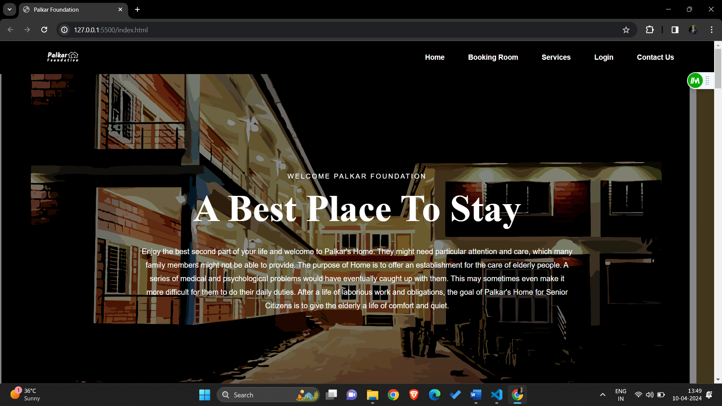

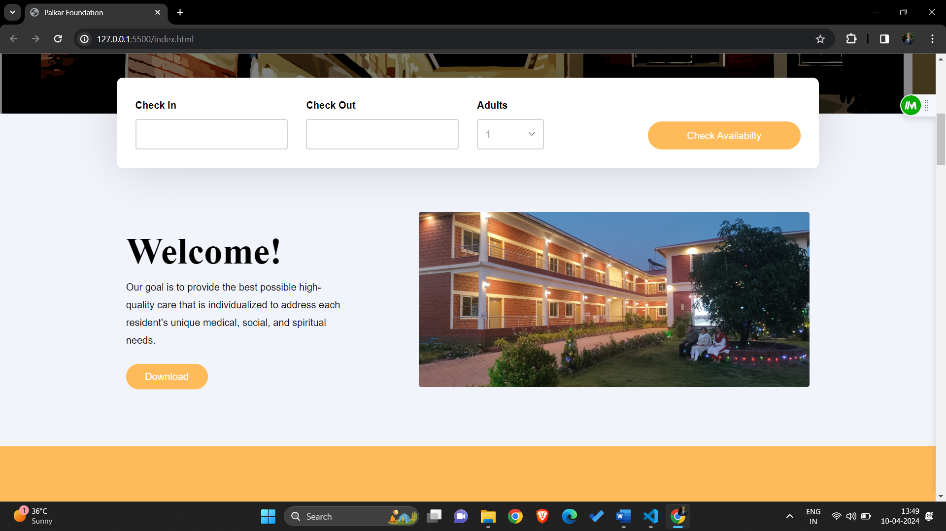

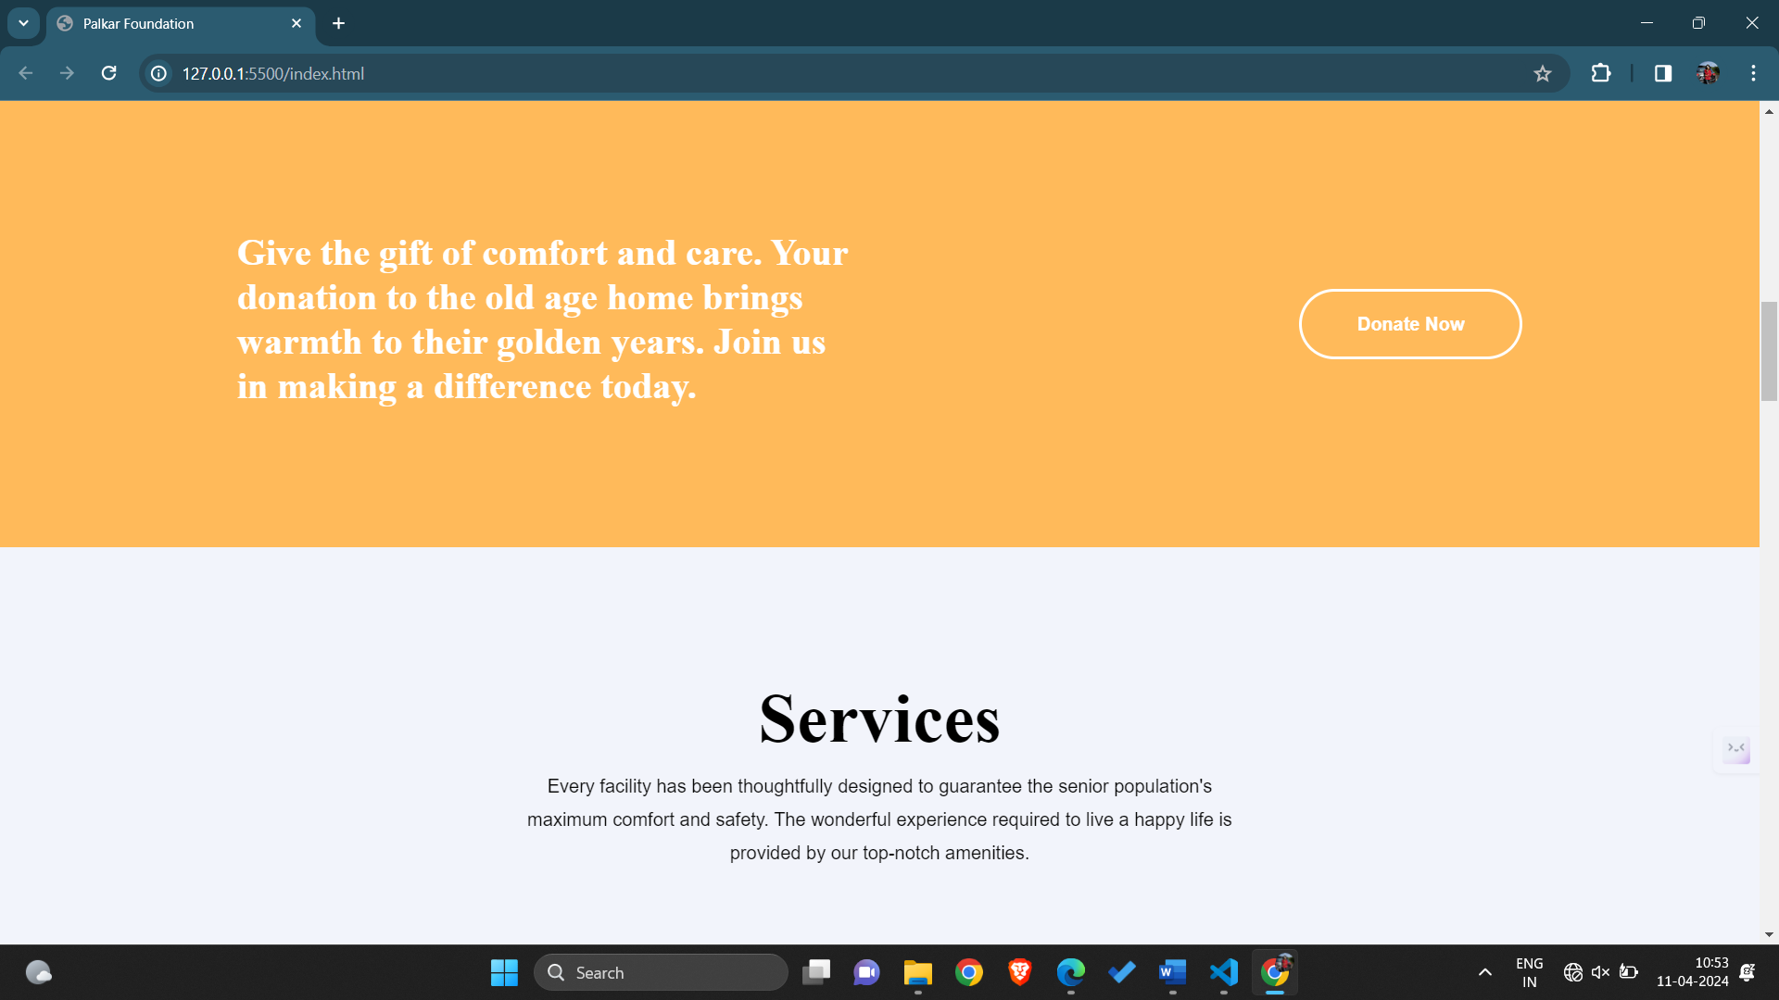

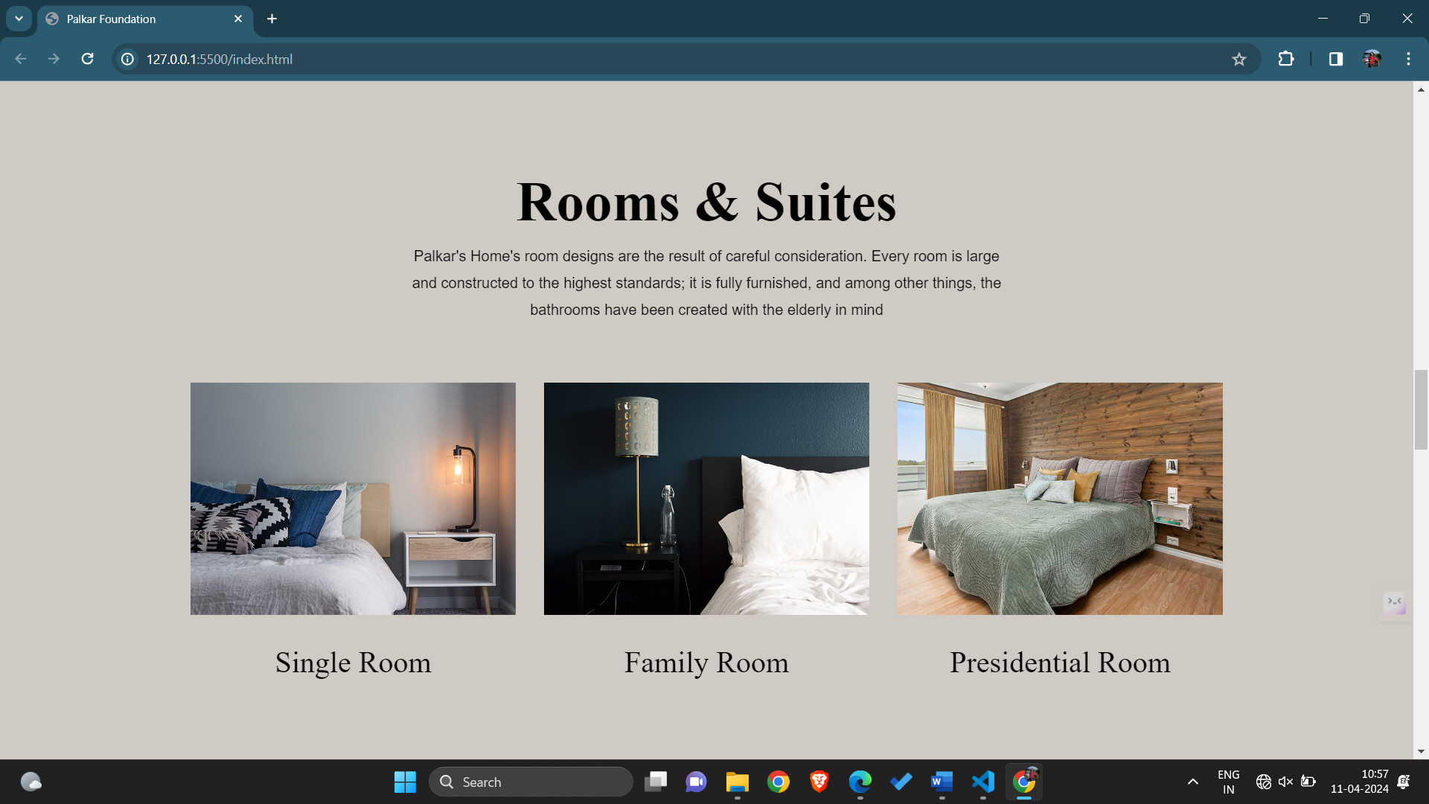

**5. CONCLUSION**

In conclusion, my Web-Dev internship has been an immensely rewarding journey, marking a significant milestone in my career development. Through hands-on experience with real-world projects, I have not only refined my technical skills in HTML, CSS, and JavaScript & MERN but also gained proficiency in modern frameworks and tools that are crucial for today's web development standards. The personal and professional growth I have experienced underscores the importance of practical, real-world learning opportunities in preparing aspiring developers for the challenges and opportunities of the tech industry.